Project Report
Of
Snack Squad: A Customizable Snack Ordering and Delivery App

Index
- INTRODUCTION
  - Project Overview
  - Purpose
- LITERATURE SURVEY
  - Existing problem
  - References
  - Problem Statement Definition
- IDEATION & PROPOSED SOLUTION
  - Empathy Map Canvas
  - Ideation & Brainstorming
- REQUIREMENT ANALYSIS
  - Functional requirement
  - Non-Functional requirements
- PROJECT DESIGN
  - Data Flow Diagrams & User Stories
  - Solution Architecture
- PROJECT PLANNING & SCHEDULING
  - Technical Architecture
  - Sprint Planning & Estimation
  - Sprint Delivery Schedule
- CODING & SOLUTIONING
- PERFORMANCE TESTING
  - Performace Metrics
- RESULTS
  - Output Screenshots
- ADVANTAGES & DISADVANTAGES
- CONCLUSION
- FUTURE SCOPE
- APPENDIX
Source Code
GitHub & Project Demo Link

1. INTRODUCTION

1.1 Project Overview
Snack Squad is a snack ordering and delivery application designed for social events like movie nights, parties, or casual meetups. The app simplifies snack discovery, selection, customization, and timely doorstep delivery.

1.2 Purpose
The purpose of this project is to provide users with a one-stop solution for ordering snacks conveniently through a mobile or web interface, enhancing user experience with real-time updates, multiple payment methods, and personalized recommendations.

2. LITERATURE SURVEY

2.1 Existing Problem
Users often need to visit multiple apps or stores to get a variety of snacks for group events. Coordination, availability, and delivery delays often disrupt the experience.

2.2 References
- https://developer.ibm.com/patterns/
- https://www.atlassian.com/agile/
- Online food delivery apps like Zomato, Swiggy

2.3 Problem Statement Definition
To develop a customizable snack ordering application that streamlines the selection, payment, and delivery process using modern technologies, ensuring speed, convenience, and variety.

3. IDEATION & PROPOSED SOLUTION

3.1 Empathy Map Canvas
Empathizes with party hosts or casual users who need fast and reliable snack solutions. Understands pain points like limited options, delivery delays, and interface clutter.
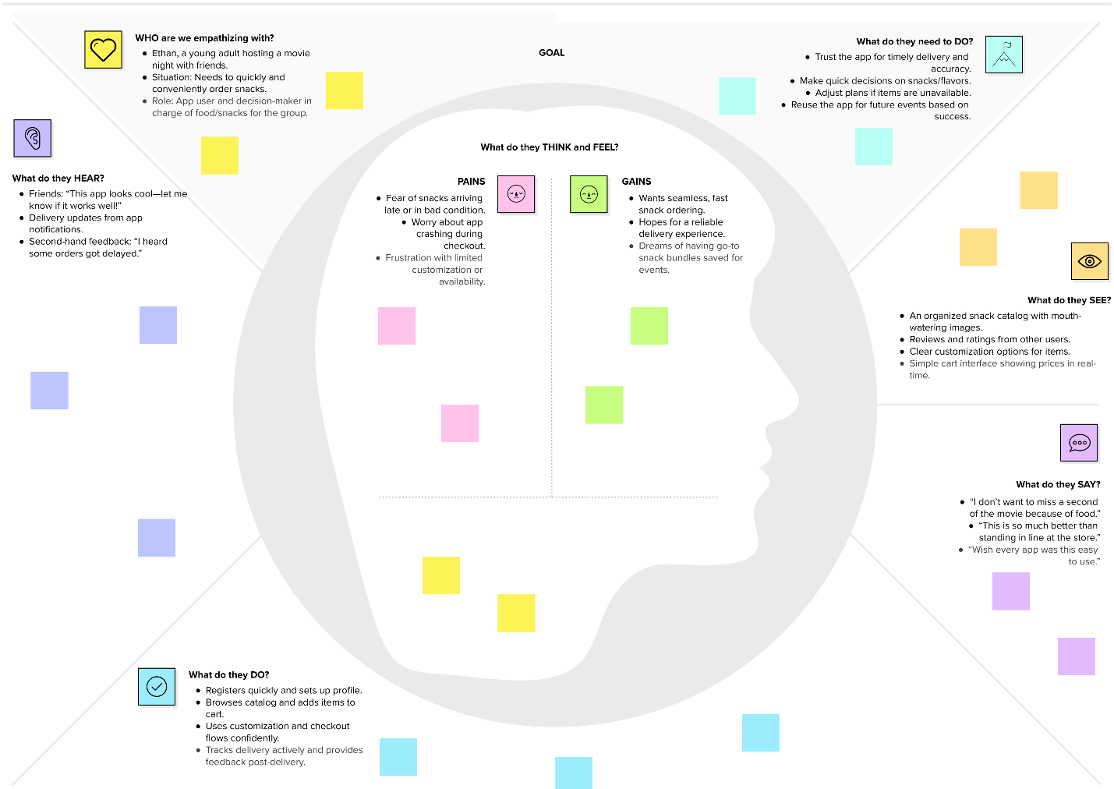

3.2 Ideation & Brainstorming
Brainstormed features like:
- Customizable snack combos
- Real-time availability
- Social media login
- Admin panel for stock tracking
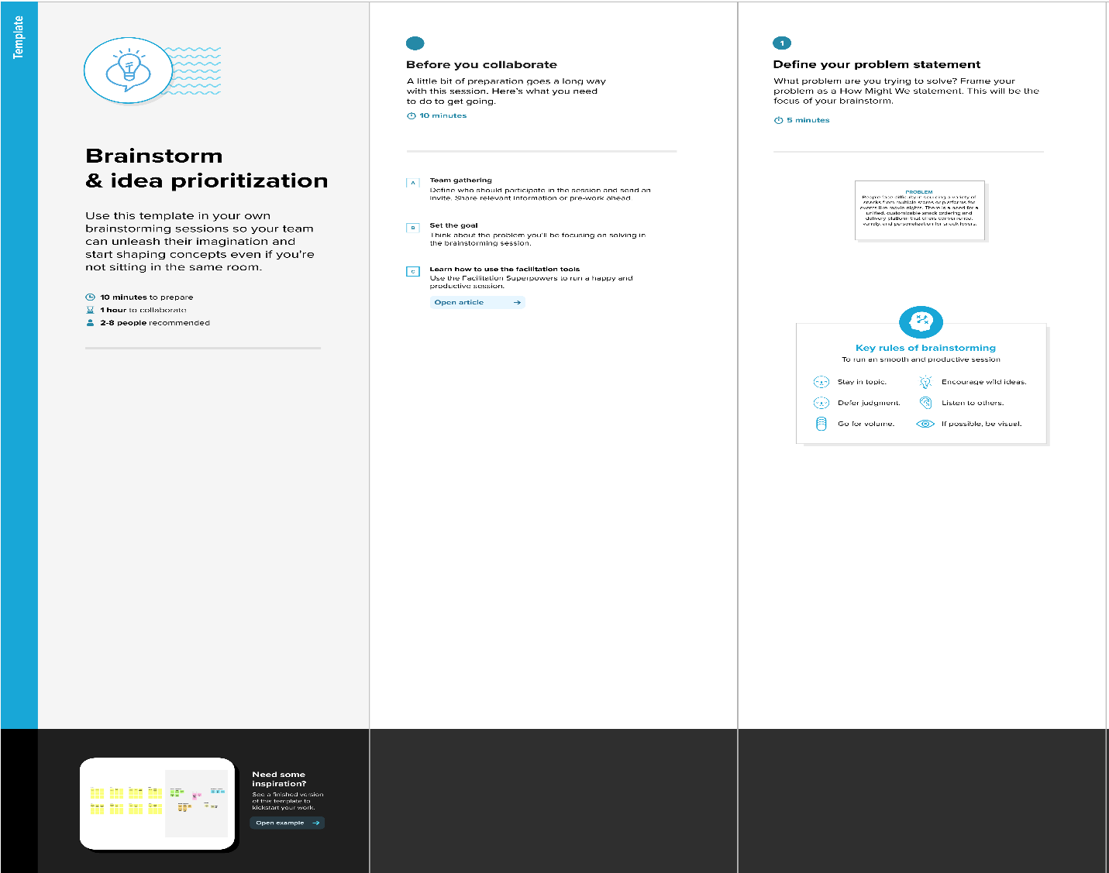
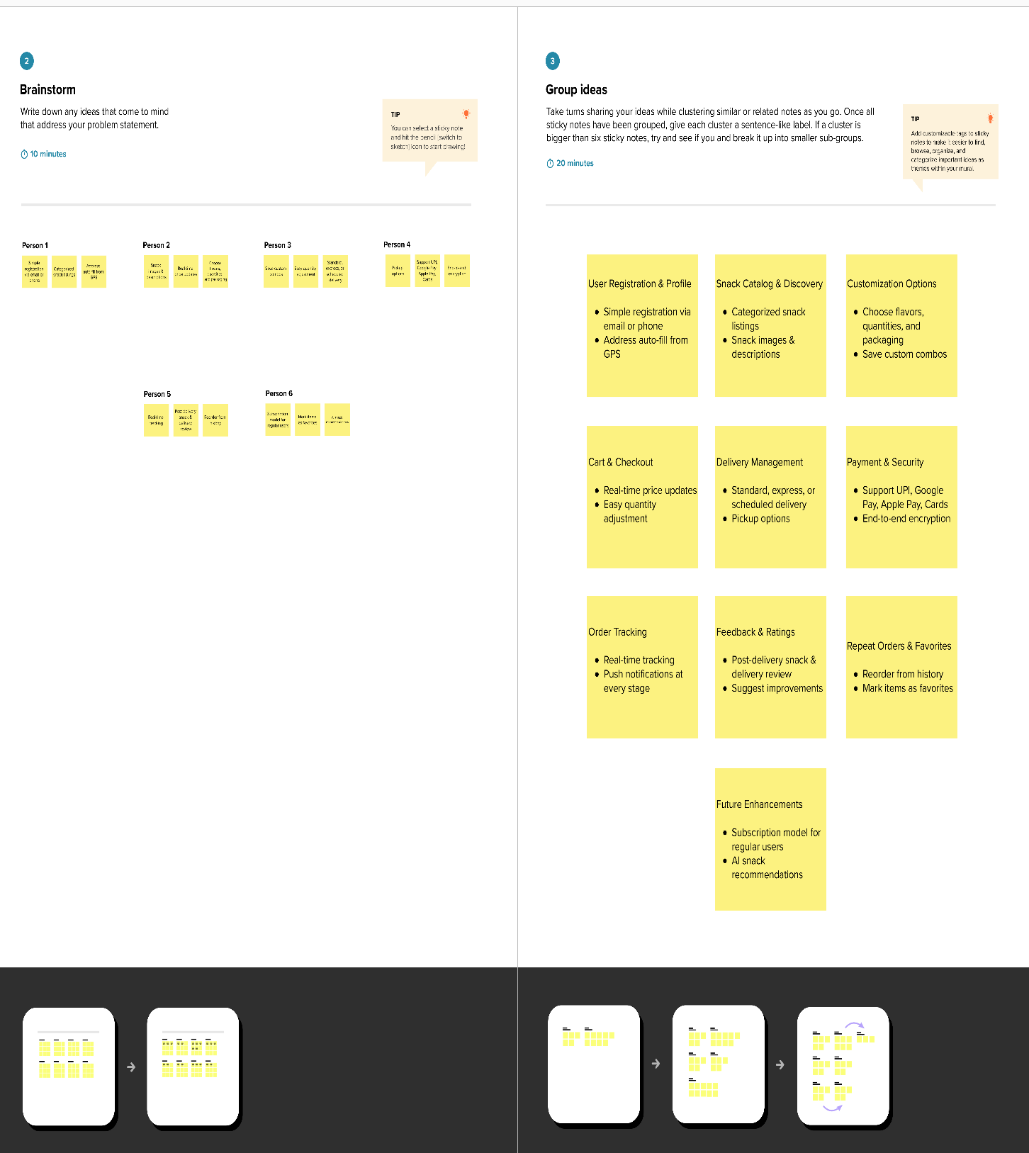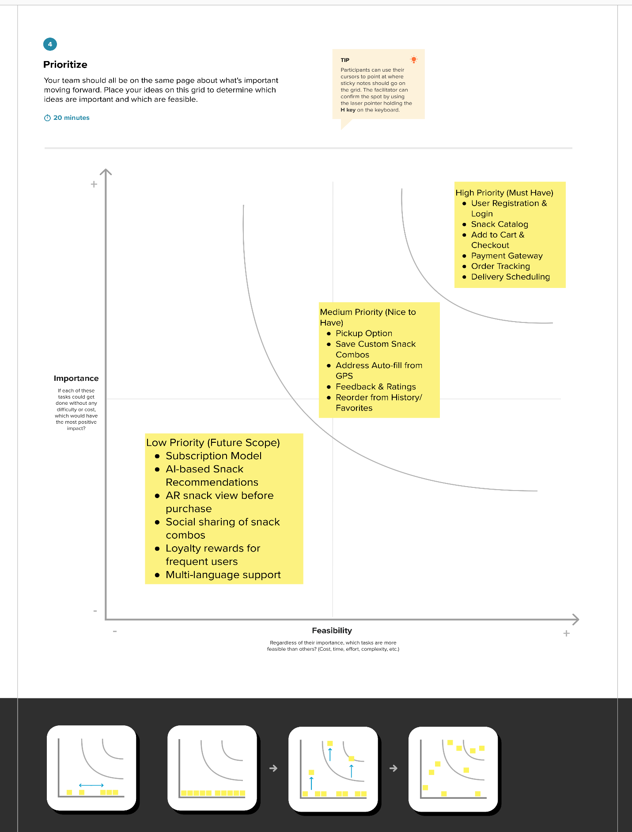

4. REQUIREMENT ANALYSIS

4.1 Functional Requirements
- User Registration/Login
- Snack Catalog Browsing
- Cart & Checkout
- Order Tracking
- Admin Controls

4.2 Non-Functional Requirements
- Responsive UI
- Fast API responses
- Secure data handling (encryption)
- Scalable backend infrastructure

5. PROJECT DESIGN

5.1 Data Flow Diagrams & User Stories
- DFDs included in Appendix
- User stories explained in Sprint section
- It is included in separate documentation please check it out

5.2 Solution Architecture
- 3-tier architecture: UI, App Logic, Database
- Uses IBM Watson APIs for features like chat assistant
- Cloud storage used for data and image storage
- It is included in separate documentation please check it out

6. PROJECT PLANNING & SCHEDULING

6.1 Technical Architecture
Frontend: HTML, CSS, JavaScript Backend: Python Flask Database: MySQL (local) + IBM DB2 (cloud) Cloud: IBM Cloud Foundry

6.2 Sprint Planning & Estimation
Outlined 4 Sprints:
- Sprint-1: User Registration/Login
- Sprint-2: Dashboard & Profile
- Sprint-3: Snack Catalog, Cart
- Sprint-4: Payment & Admin
- Also It is included in separate documentation please check it out

Sprint Delivery Schedule
Each Sprint = 6 days, total = 24 days. Velocity maintained at ~1 point/day.
It is included in separate documentation please check it out

7. CODING & SOLUTIONING
6. Sample Program Code :
package com.example.snackordering
import android.annotation.SuppressLint
import android.content.Context
import android.os.Bundle
import android.widget.Toast
import androidx.activity.ComponentActivity
import androidx.activity.compose.setContent
import androidx.annotation.DrawableRes
import androidx.annotation.StringRes
import androidx.compose.foundation.Image
import androidx.compose.foundation.background
import androidx.compose.foundation.layout.*
import androidx.compose.foundation.shape.CircleShape
import androidx.compose.foundation.shape.RoundedCornerShape
import androidx.compose.material.*
import androidx.compose.material.icons.Icons
import androidx.compose.material.icons.filled.*
import androidx.compose.runtime.Composable
import androidx.compose.ui.Alignment
import androidx.compose.ui.Modifier
import androidx.compose.ui.draw.clip
import androidx.compose.ui.graphics.Color
import androidx.compose.foundation.lazy.LazyColumn
import androidx.compose.foundation.lazy.items
import androidx.compose.material.Text
import androidx.compose.ui.unit.dp
import androidx.compose.ui.graphics.RectangleShape
import androidx.compose.ui.layout.ContentScale
import androidx.compose.ui.platform.LocalContext
import androidx.compose.ui.res.painterResource
import androidx.compose.ui.res.stringResource
import androidx.compose.ui.text.font.FontWeight
import androidx.compose.ui.unit.sp
import androidx.core.content.ContextCompat.startActivity
import com.example.snackordering.ui.theme.SnackOrderingTheme
import android.content.Intent as Intent1
class MainPage : ComponentActivity() {
override fun onCreate(savedInstanceState: Bundle?) {
super.onCreate(savedInstanceState)
setContent {
SnackOrderingTheme {
// A surface container using the 'background' color from the theme
Surface(
modifier = Modifier.fillMaxSize(),
color = MaterialTheme.colors.background
) {
FinalView(this)
val context = LocalContext.current
//PopularFoodColumn(context)
}
}
}
}
}
@Composable
fun TopPart() {
Row(
modifier = Modifier
.fillMaxWidth()
.background(Color(0xffeceef0)), Arrangement.SpaceBetween
) {
Icon(
imageVector = Icons.Default.Add, contentDescription = "Menu Icon",
Modifier
.clip(CircleShape)
.size(40.dp),
tint = Color.Black,
)
Column(horizontalAlignment = Alignment.CenterHorizontally) {
Text(text = "Location", style = MaterialTheme.typography.subtitle1, color = Color.Black)
Row {
Icon(
imageVector = Icons.Default.LocationOn,
contentDescription = "Location",
tint = Color.Red,
)
Text(text = "Accra" , color = Color.Black)
}
}
Icon(
imageVector = Icons.Default.Notifications, contentDescription = "Notification Icon",
Modifier
.size(45.dp),
tint = Color.Black,
)
}
}
@Composable
fun CardPart() {
Card(modifier = Modifier.size(width = 310.dp, height = 150.dp), RoundedCornerShape(20.dp)) {
Row(modifier = Modifier.padding(10.dp), Arrangement.SpaceBetween) {
Column(verticalArrangement = Arrangement.spacedBy(12.dp)) {
Text(text = "Get Special Discounts")
Text(text = "up to 85%", style = MaterialTheme.typography.h5)
Button(onClick = {}, colors = ButtonDefaults.buttonColors(Color.White)) {
Text(text = "Claim voucher", color = MaterialTheme.colors.surface)
}
}
Image(
painter = painterResource(id = R.drawable.food_tip_im),
contentDescription = "Food Image", Modifier.size(width = 100.dp, height = 200.dp)
)
}
}
}
@Composable
fun PopularFood(
@DrawableRes drawable: Int,
@StringRes text1: Int,
context: Context
) {
Card(
modifier = Modifier
.padding(top=20.dp, bottom = 20.dp, start = 65.dp)
.width(250.dp)
) {
Column(
verticalArrangement = Arrangement.Top,
horizontalAlignment = Alignment.CenterHorizontally
) {
Spacer(modifier = Modifier.padding(vertical = 5.dp))
Row(
modifier = Modifier
.fillMaxWidth(0.7f), Arrangement.End
) {
Icon(
imageVector = Icons.Default.Star,
contentDescription = "Star Icon",
tint = Color.Yellow
)
Text(text = "4.3", fontWeight = FontWeight.Black)
}
Image(
painter = painterResource(id = drawable),
contentDescription = "Food Image",
contentScale = ContentScale.Crop,
modifier = Modifier
.size(100.dp)
.clip(CircleShape)
)
Text(text = stringResource(id = text1), fontWeight = FontWeight.Bold)
Row(modifier = Modifier.fillMaxWidth(0.7f), Arrangement.SpaceBetween) {
/*TODO Implement Prices for each card*/
Text(
text = "$50",
style = MaterialTheme.typography.h6,
fontWeight = FontWeight.Bold,
fontSize = 18.sp
)
IconButton(onClick = {
//var no=FoodList.lastIndex;
//Toast.
val intent = Intent1(context, TargetActivity::class.java)
context.startActivity(intent)
}) {
Icon(
imageVector = Icons.Default.ShoppingCart,
contentDescription = "shopping cart",
)
}
}
}
}
}
private val FoodList = listOf(
R.drawable.sandwish to R.string.sandwich,
R.drawable.sandwish to R.string.burgers,
R.drawable.pack to R.string.pack,
R.drawable.pasta to R.string.pasta,
R.drawable.tequila to R.string.tequila,
R.drawable.wine to R.string.wine,
R.drawable.salad to R.string.salad,
R.drawable.pop to R.string.popcorn
).map { DrawableStringPair(it.first, it.second) }
private data class DrawableStringPair(
@DrawableRes val drawable: Int,
@StringRes val text1: Int
)
@Composable
fun App(context: Context) {
Column(
modifier = Modifier
.fillMaxSize()
.background(Color(0xffeceef0))
.padding(10.dp),
verticalArrangement = Arrangement.Top,
horizontalAlignment = Alignment.CenterHorizontally
) {
Surface(modifier = Modifier, elevation = 5.dp) {
TopPart()
}
Spacer(modifier = Modifier.padding(10.dp))
CardPart()
Spacer(modifier = Modifier.padding(10.dp))
Row(modifier = Modifier.fillMaxWidth(), Arrangement.SpaceBetween) {
Text(text = "Popular Food", style = MaterialTheme.typography.h5, color = Color.Black)
Text(text = "view all", style = MaterialTheme.typography.subtitle1, color = Color.Black)
}
Spacer(modifier = Modifier.padding(10.dp))
PopularFoodColumn(context) // <- call the function with parentheses
}
}
@Composable
fun PopularFoodColumn(context: Context) {
LazyColumn(
modifier = Modifier.fillMaxSize(),
content = {
items(FoodList) { item ->
PopularFood(context = context,drawable = item.drawable, text1 = item.text1)
abstract class Context
}
},
verticalArrangement = Arrangement.spacedBy(16.dp))
}
@SuppressLint("UnusedMaterialScaffoldPaddingParameter")
@Composable
fun FinalView(mainPage: MainPage) {
SnackOrderingTheme {
Scaffold() {
val context = LocalContext.current
App(context)
}
}
}

8. PERFORMANCE TESTING

8.1 Performance Metrics
- Load test: 100 users/sec
- Avg response time: < 1.2s
- Cache implemented for repeated snack item queries

9. RESULTS

9.1 Output Screenshots
- Attached in Appendix:
Registration Page Login Page
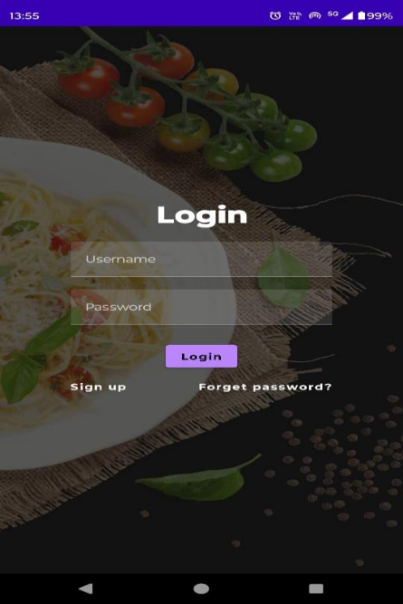
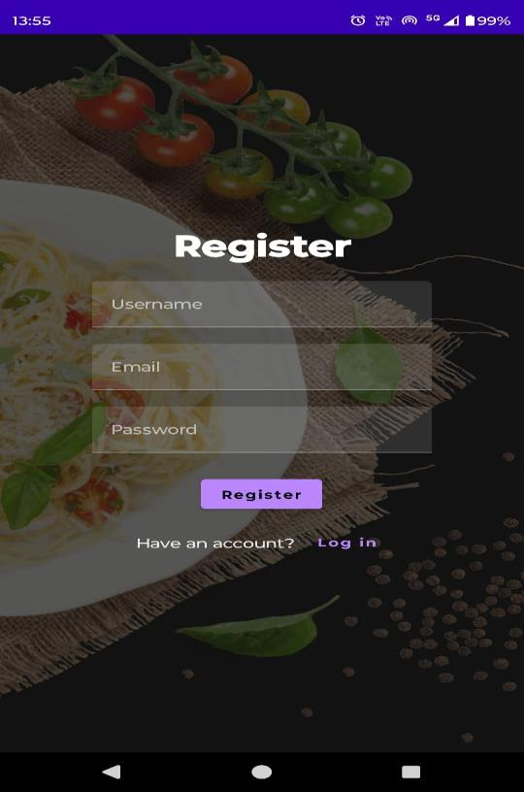
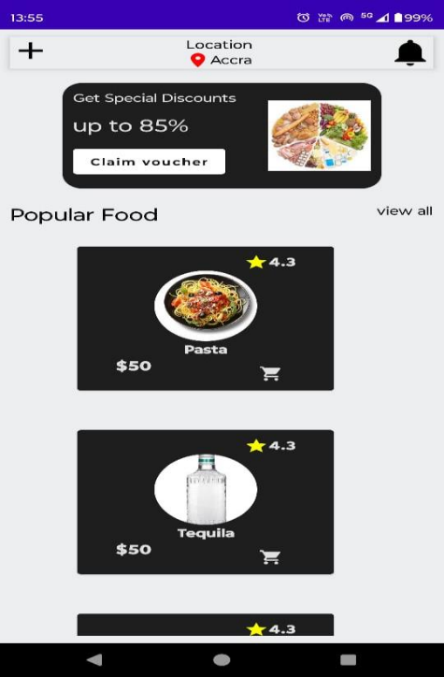
Snack Catalog Cart and Payment
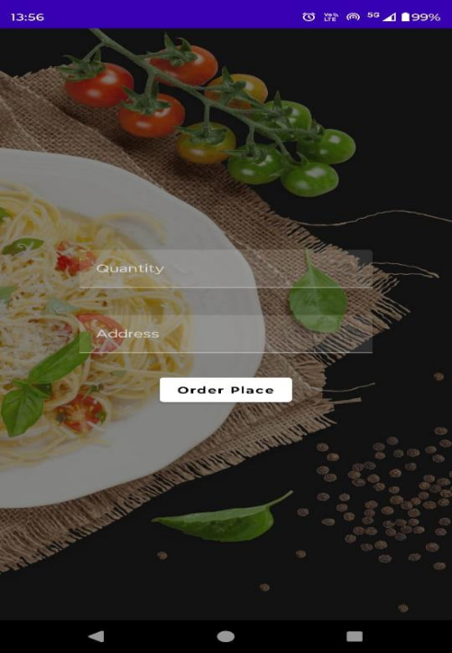

10. ADVANTAGES & DISADVANTAGES
Advantages:
- Fast snack discovery
- Customization available
- Real-time order tracking
Disadvantages:
- Requires stable internet
- Dependent on delivery service integration

11. CONCLUSION
The Snack Squad application represents a significant advancement in the convenience and
personalization of snack ordering. Through its innovative features, such as customizable orders,
real-time tracking, and secure payment processing, Snack Squad not only meets the current
demands of snack enthusiasts but also sets a new benchmark for user satisfaction in the food
delivery industry. By leveraging cutting-edge technology and focusing on a seamless user
experience, Snack Squad ensures that users can enjoy their favorite snacks with minimal hassle
and maximum satisfaction. Our commitment to quality, security, and continuous improvement
underpins the development and deployment of this application, making Snack Squad a pioneering solution in the market.

12. FUTURE SCOPE
To continually improve and adapt to user needs, several enhancements are planned for
the future development of Snack Squad:
• Enhanced Personalization: Incorporating machine learning algorithms to better
understand user preferences and provide more accurate recommendations.
• Expanded Snack Variety: Partnering with more local and international snack vendors to
offer a wider range of options.
• Subscription Services: Introducing subscription-based snack delivery plans for regular
users, providing convenience and cost savings.
• Advanced Order Customization: Adding more options for order customization, such as
allergen filters and detailed nutritional information.
• Loyalty Programs: Implementing a rewards system to incentivize repeat orders and
enhance user engagement.
• Voice Ordering: Integrating with voice assistants to allow users to place orders via voice
commands for added convenience.
• Sustainability Initiatives: Partnering with eco-friendly delivery services and offering
sustainable packaging options to minimize environmental impact.
• Improved Security Measures: Continuously updating security protocols to protect user
data and ensure safe transactions.
• Global Expansion: Scaling the app to support multiple languages and currencies,
enabling Snack Squad to serve users worldwide.

13. APPENDIX
Source Code: Attached ZIP or via GitHub
Demo Link:
https://drive.google.com/file/d/1PgRy7hdK27ryYQoqU-XiOfkHluEWE_v8/view?usp=sharing

